**SPOTIFY MUSIC RECOMMENDATION SYSTEM**

A Project Report

submitted in partial fulfillment of the requirements

of

……………. Track Name ……

by

**Name of Student: HATHIM RIYAS S**

**Email id: hathimriyas194@gmail.com**

**NM Id: 0EB3AACBA26635DBC5C497F9129525B9**

Under the Guidance of

**(P.Raja, Master Trainer, Edunet Foundation)**

**ACKNOWLEDGEMENT**

We would like to take this opportunity to express our deep sense of gratitude to all individuals who helped us directly or indirectly during this thesis work.

I am really grateful and wish my profound indebtedness to Supervisor**P.RAJA** Deep Knowledge & keen interest of my supervisor in the field of Machine Learning to carry out this project. His endless patience, scholarly guidance, continual encouragement, constant and energetic supervision, constructive criticism, valuable advice, reading many inferior drafts and correcting them at all stages have made it possible to complete this project.

I would like to express my heartiest gratitude to **Mohamed Azarudheen**, Department of MECHANICAL, for his kind help to finish my project.

I would also generously welcome each one of those individuals who have helped me straightforwardly or in a roundabout way in making this project a win. In this unique situation, I might want to thank the various staff individuals, both educating and non-instructing, which have developed their convenient help and facilitated my undertaking.

Finally, I must acknowledge with due respect the constant support and patients of my parents.

HATHIM RIYAS S

### ABSTRACT

Recommendation systems have emerged as a result of the large amount of data available on the Internet. Many firms, such as Amazon and Flip-kart for e-commerce, wynk’s music and gaana.com for music streaming, are now employing recommend-er systems to their advantage. We provide a framework in this particular situation that can then recommend new melodies to clients based on their preferences. This initiative primarily focuses on providing music recommendations to music fans in order to assist them in listening to tracks that they may enjoy. Clients can use this framework to identify new collections of tunes, making the melodic list available for tuning in.

Music is life for music fans, and it has become a larger part of everyone's lives. Music helps us tune in to the cosmos, and the best part about music is that nothing can soothe you like a soothing melody. We chose to do this project because of all the positive aspects of music and the increasing demand for recommend-er systems on the market. The report comprises a topic description, and a full summary of the work completed thus far. The paper includes thorough explanations of the work completed, including snapshots of implementations, various techniques, and tools used thus far. The project schedule and deliverable are also included in the report. The major goal of music recommendation in this study is to provide strong human-computer interaction and deliver good recommendations to users. It is fluid and can be changed by variables other than the listening history of users or songs.

Abstract:3

**TABLE OF CONTENTS**

List of Figure: 4

|  |  |  |
| --- | --- | --- |
| **S.NO** | **CONTENT** | **PG.NO** |
| 1 | CHAPTER-1: INTRODUCTION   * 1. PROBLEM STATEMENT   2. OBJECTIVES   3. SCOPE OF THE OBJECT | **5**  **5**  **8**  **10** |
| 2 | CHAPTER-2: LITERATURE SURVEY | **11** |
| 3 | CHAPTER-3: PROPOSED METHODOLOGY | **14** |
| 4 | CHAPTER-4: IMPLEMENTATION | **17** |
| 5 | CHAPTER-5: DISSCUSION AND CONCLUSION | **22** |

**LIST OF FIGURES**

|  |  |  |
| --- | --- | --- |
| **Figure No** | **Name of the Figure** | **Page No.** |
|  | GRAPH PLOTTING | **13** |
|  | PLOTS BETWEEN LOUDNESS AND ENERGY | **14** |
|  | PLOTS BETWEEN ACOUSTICNESS AND ENERGY | **14** |
|  | PIECHART OF UNDERGROUND RAP | **19** |

**CHAPTER 1**

**INTRODUCTION**

**MUSIC RECOMMENDATION SYSTEM:**

Music recommendation systems have become essential tools in the digital music landscape, enabling users to navigate vast libraries and discover new artists and genres tailored to their preferences. With millions of songs available across numerous platforms, these systems help users find music that resonates with their tastes, thereby enhancing their listening experience.

At their core, music recommendation systems analyze user behavior, such as listening history, ratings, and playlists, to provide personalized suggestions. They leverage algorithms that can identify patterns and similarities in both user preferences and music characteristics. This personalization not only helps users discover new tracks but also fosters deeper engagement with the music platform.

As the music industry continues to evolve, the importance of effective recommendation systems grows. They play a crucial role in driving user satisfaction, increasing retention rates, and ultimately influencing music consumption trends. This project aims to develop a sophisticated music recommendation system that combines various techniques to deliver relevant and engaging music suggestions to users, enhancing their overall experience in a crowded musical landscape.

**1.1 PROBLEM STATEMENT:**

With commercial music streaming service which can be accessed from mobile devices,the availability of digital music currently is abundant compared to previous era. Sortingout all this digital music is a very time-consuming and causes information fatigue.Therefore, it is very useful to develop a music recommender system that can search in the music libraries automatically and suggest suitable songs to users.

In the long-term, the goal is not only to recommend existing songs but also to generate songs adapted to the musical taste of the user. During this master thesis I focused on the recommendation part while exchanging with a colleague in charge of thegeneration part. The music which selected by the user is used as the basis music for recommendations. The features of basis music are extraction vector is obtained from the best genre prediction model in previous step. Next, the values of cosine similarity are sorted from the largest to the smallest value. The future of the project will consisting gathering these two parts in order to have a fully functional recommendation system.

Because real-time data changes rapidly, an algorithm based on it must be efficient. We want advice that are relevant to the current situation rather than prior situations. Many researchers are presently focusing on machine learning approaches such as neural networks, and they are also becoming more prominent in the field of recommender systems. In terms of results, the major goal was to establish a framework for consumers to use in order to assist them find the ideal tunes for them. This project seeks to discover the correlation and similarity between different songs, and then construct a recommendation system framework that suggests new music for your Spotify playlist based on that information.

They can not only manage the ever-increasing amount of data, but they also increase in quality in proportion to the amount of data evaluated, thanks to the learning algorithms. Indeed, during years, in order to choose music, restaurants, movies, etc.. We have been asking our friends, family, and colleagues to recommend something they liked. And it is this mechanism that is attempted to be reproduced here. Netflix was a pioneer of this method (based on stars given by other users) but it is now widely used, including for Spotify’s Discover Weekly. Collaborative filtering makes suggestions based on the collaborative power of the available evaluation by users.

Machine learning has become significantly more viable than it has been traditionally as the amount of data has expanded and the processing capacity of computers has improved. The algorithms are made to look for patterns.

Because our music choices and our present emotional state are so closely linked, realtime data sources are extremely important for music suggestions. Certain songs or styles of music can affect our mood in various ways, and our musical choices are frequently linked to our mood.

Music selections are also linked to the listener's current activities. Even if we have a certain musical taste, our tastes will shift depending on what we are doing. When a person is working out at the gym, for example, they will likely listen to different tunes than when they are attempting to go asleep at night.

The aim of this thesis is to explore the different recommendation approaches, the available datasets, the ways to take into account the user’s preferences and the machine learning methods in order to build a suitable recommendation system. The music which selected by the user is used as the basis music for recommendations. The features of basis music are extraction vector is obtained from the best genre prediction model in previous step. Next, the values of cosine similarity are sorted from the largest to the smallest value. One important part was only dedicated to determine how to evaluate this recommendation system. This project will be introduced to the members of the company and will take the form of an application. The user will be asked to upload a music and the application will recommend some music to be listened to afterwards.

**1.2 OBJECTIVES:**

The goal of this project was to learn about machine learning and its fundamental concepts, as well as numerous data mining approaches and algorithms. Another goal was to become familiar with a variety of machine learning algorithms and how to use them. Learning algorithms alone does not make you an engineer; the true challenge is determining which method is best for a certain project.

In terms of results, the major goal was to establish a framework for consumers to use in order to assist them find the ideal tunes for them. This project seeks to discover the correlation and similarity between different songs, and then construct a recommendation system framework that suggests new music for your Spotify playlist based on that information.

Long-term, the objective is to not just propose current songs, but also to create songs according to the user's musical preferences. Throughout my master's thesis, I concentrated on the recommendation section while corresponding with a colleague who was in charge of the generating section. The project's future will consist of bringing these two components together to create a fully working recommendation system.

Indeed, during years, in order to choose music, restaurants, movies, etc.. We have been asking our friends, family, and colleagues to recommend something they liked. And it is this mechanism that is attempted to be reproduced here. Netflix was a pioneer of this method (based on stars given by other users) but it is now widely used, including for Spotify’s Discover Weekly. Collaborative filtering makes suggestions based on the collaborative power of the available evaluation by users.

The objective is to recommend the user the types of songs that he would like by comparing his taste i.e., his playlist of music with the songs available in the dataset. By using music recommender system, the music provider can predict and then offer the appropriate songs to their users based on the characteristics of the music that has been heard previously.

Major section was devoted to determining how to assess this recommendation system. This project will be presented to the company's employees in the form of an application. The user will be requested to submit a song, and the program will then offer several songs to listen to.

The idea is not just to recommend current songs but also to produce songs based on the user's musical preferences. During this master's thesis, I concentrated on the suggestion portion while corresponding with a colleague in charge of the generating portion. The project's future will consist of combining these two components to create a fully working recommendation system.

Only one significant section was devoted to determining how to assess this suggestion system. This project will be presented to the company's employees in the form of an application. The user will be invited to upload music, following which the program will suggest some songs to listen to.

The recommendation systems that really emerged in the 1990s have developed strongly in recent years, especially with the introduction of Machine Learning and networks. Indeed, on the one hand, the growing use of the current digital environment, characterized by an overabundance of information has allowed us to obtain large user databases. On the other hand, the increase in computing power made it possible to process these data especially thanks to Machine Learning when human capacities were no longer able to carry out an exhaustive analysis of so much information.

**1.3 SCOPE OF THE PROJECT:**

The scope of a music recommendation system encompasses several key areas:

1. User Personalization: Tailoring recommendations based on individual listening habits, preferences, and behaviors.

2. Data Analysis: Utilizing algorithms and machine learning to analyze large datasets of music tracks, user interactions, and contextual factors.

3. Content-Based Filtering: Recommending music similar to what a user has liked based on attributes like genre, tempo, and instrumentation.

4. Collaborative Filtering: Leveraging user ratings and preferences to suggest music that similar users have enjoyed.

5. Context Awareness: Integrating situational factors (time of day, location, activity) to enhance recommendations.

6. Diversity and Serendipity: Balancing popular recommendations with lesser-known tracks to enrich user experience.

7. Cross-Platform Integration: Ensuring seamless recommendations across different devices and platforms (apps, websites, smart speakers).

8. User Engagement: Developing features that encourage user interaction, such as playlists, social sharing, and feedback mechanisms.

9. Continuous Learning: Implementing systems that adapt over time based on evolving user tastes and emerging music trends.

10. Market Trends and Analytics: Analyzing broader trends in music consumption to inform recommendation strategies and enhance user satisfaction.

**CHAPTER 02**

**LITERATURE SURVEY:**

We were awestruck with Spotify’s recommendation engine. We always wondered how Spotify manages to recommend that perfect song, playlist or even that ‘daily mix’ . We now have more technology than ever before to ensure that if you’re the smallest, strangest musician in the world, doing something that only 20 people in the world will dig, we can now find those 20 people and connect the dots betweenthe artist and listeners. This has been the motivation for this project to use various machine learning techniques and to develop a music recommendation engine similar to that of Spotify, which takes music listening experience to another level. Music Recommendation Systems.

Recommender systems help consumers deal with the problem of information overload by providing them with individualised, unique content and service suggestions. Various methods for developing recommendation systems have recently been created, including collaborative filtering, content-based filtering, and hybrid filtering. The collaborative filtering approach is the most developed and widely used. Collaborative filtering suggests things by locating other users who have similar tastes to the current user and using their recommendations. Collaborative recommender systems have been used in a variety of settings. problems – new items and new users. The first problem refers to the new items that are meant to be recommended, but the information that is associated with them,.

The common characteristics in these systems are constant when using users’ preferences compared with users’ context (location, mood, weather, etc.). For instance, in the library when people are sitting there maybe they need quiet and melodious music to listen according to the environment where they are in. Last.fm, All music, Spotify, Pandora and Shazam are commercial music recommendation systems which are considered to be excellent systems by focusing on the music already played in order to help the users to find more music. Users are able to connect to a web-based music streaming service to access the recommendations. All the tracks that are played on this stream are recommended.

It is Based on songs or artists which users either upload from your iTunes playlists or add as favourites on the site where users start managing their library of music with tags and keep tracking of the music the friends who listening to and getting multiple recommendations per song played. Additionally, this app filters recommendations by decade, genre, and popularity, as well as builds fabulous playlists (Song et al., 2012).t has been found that CF generally gives better recommendations than CB. However, this is only true if there is usage data available, such as the ratings given to previous tracks. If this is not the case, then it will not prove accurate results and, consequently, suffer from the Cold-Start problem, which includes two categories of problems – new items and new users. The first problem refers to the new items that are meant to be recommended, but the information that is associated with them.

**GRAPH PLOTTING**

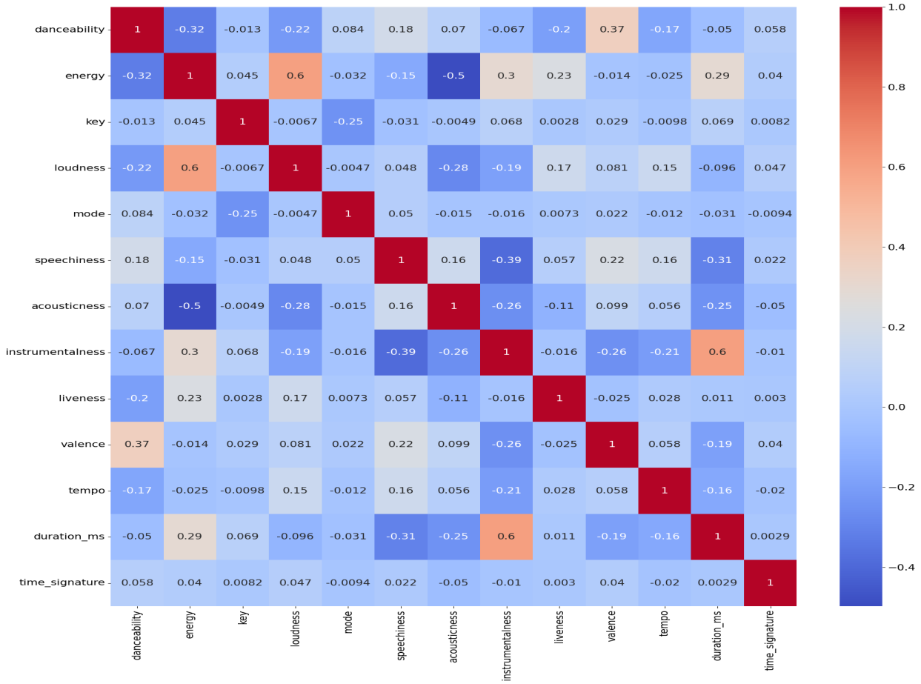

Meanwhile, many researchers have used social media (Twitter & Facebook) to identify user’s mood (tension, depression, anger, vigor, fatigue, confusion) and also identify user’s personality (openness, conscientiousness, extraversion,agreeableness, neuroticism) where these are very important factors which influence on user’s music taste (Wang et al., 2014; Roberts et al., 2012; Pandarachalil et al., 2015; Ross et al., 2009; Bachrach et al., 2012; Back et al., 2010) and also contextual features (location & event) can lead to different emotional effects due to objective features of the situation or subjective perceptions of the listeners (Scherer et al., 2001).

Music lyrics are also considered to be one of emotional presentation because they include some kinds of implicit thinking, thus we can fully understand emotions and their associated thinking in each song (Nunes and Jannach, 2017; Tintarev and Masthoff, 2008). Cano et al. (2017) mentioned that there is a strong relation between the user mood and listening to the music

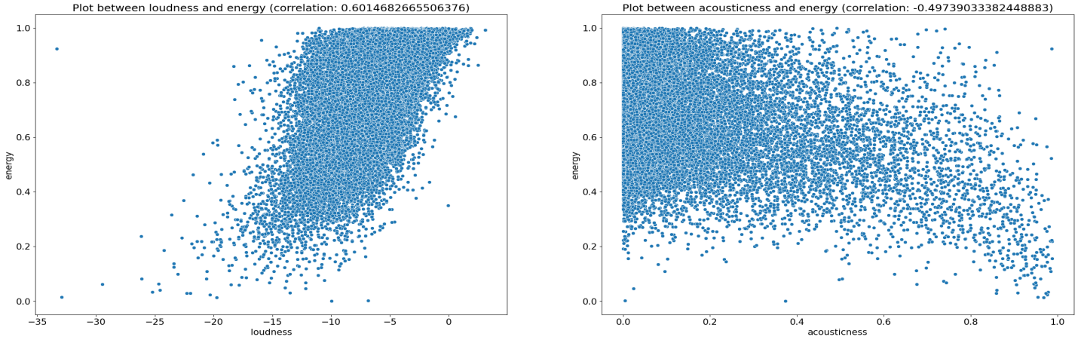.

The people may want to listen to music which has the same mood of them when they are in specific mood and in contrast the people want to listen to different kind of music which encourage them to enhance their mood and this thing depend on the psychological studies and therefore, the author produced a contextual mood-based music recommender system which is able to regulate the driver’s mood and also try to put the driver in a positive mood when driving because listening to the music while driving has always been one of the most favourite activities carried out by people. Finally, similarly, active learning approaches suffer from various limitations.

**CHAPTER-03**

**PROPOSED METHODOLOGY**

**1. Project Definition:**

**Objective:** Define the purpose of the recommendation system (e.g., personalized music suggestions).

**Scope:** Identify the types of data to be used (e.g., user preferences, song features).

**2. Data Collection:**

**User Data:** Gather user profiles, listening history, and ratings.

**Music Data:** Collect metadata (e.g., genre, artist, album) and audio features (e.g., tempo, key).

**APIs:** Use music APIs (like Spotify or Last.fm) for real-time data.

**3.Data Pre processing:**

**Cleaning:** Remove duplicates, handle missing values, and standardize formats.

**Transformation:** Convert categorical data into numerical format (e.g., one-hot encoding).

**Normalization:** Scale numerical features to ensure uniformity.

**4. Exploratory Data Analysis (EDA):**

Analyze user behavior patterns and preferences.

Visualize data to identify trends, correlations, and outliers.

**5. Recommendation Algorithms:**

**Collaborative Filtering:**

**User-Based:** Recommend based on similar user preferences.

**Item-Based:** Recommend songs similar to those a user has liked.

**Content-Based Filtering:**Recommend songs based on features of songs the user has previously liked.

**Hybrid Approaches:** Combine collaborative and content-based methods for improved accuracy.

**6. Model Selection and Training:**

Choose algorithms (e.g., matrix factorization, deep learning models).

Split data into training, validation, and test sets.

Train models and tune hyperparameters for optimal performance.

**7. Evaluation:**

Metrics: Use precision, recall, F1-score, and mean average precision to evaluate model performance.

A/B Testing: Implement user testing to compare different recommendation strategies.

**8. Implementation:**

Develop a user-friendly interface for the recommendation system.

Ensure scalability for handling a large volume of users and data.

**9. Deployment:**

Host the system on a cloud platform for accessibility.

Monitor system performance and user interactions.

**10. Feedback Loop:**

Continuously gather user feedback to refine recommendations.

Regularly update models with new data to improve accuracy.

**11. Documentation and Reporting:**

Document the methodology, model architectures.

**CHAPTER-04**

**IMPLEMENTATION:**

The recommender system is done by calculating cosine similarity of extraction features (equation 1) from one music to another music. The extraction features are in vector form; thus, it is possible to calculate their distance. First, we chose one music for each genre as the basis for the recommender system. Next the prediction of the basis music genre is calculated based on neural networks. The feature vectors that produce before the classification layer are used as a basis for recommendations. After the basis music features are obtained, cosine similarity calculations are performed on other music features.

The study of the content of the items considered for suggestion is content-based recommendation. This method attempts to deduce the user's tastes in order to suggest goods that are similar in content to those they have previously enjoyed. This approach does not require listener input; it is only based on sound similarity, which is calculated using information taken from previously heard songs.

The commonalities between the components are used in this strategy. It is a question of extracting characteristics that best characterize the music in order to assess similarities. The Machine Learning algorithms then suggest the item that is most similar to what the consumer already loves.

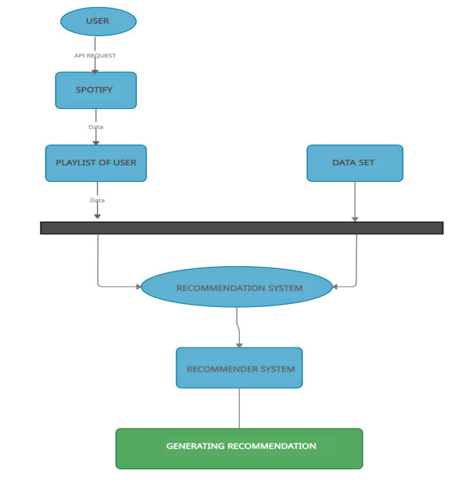

**FLOW GRAPH OF THE PROJECT**

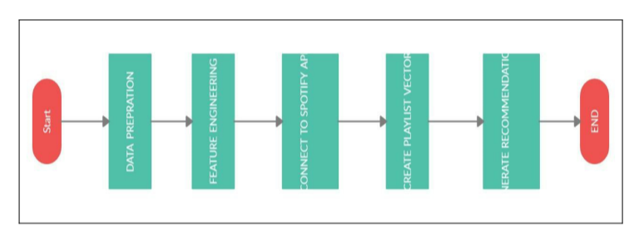

**PIECHART:**

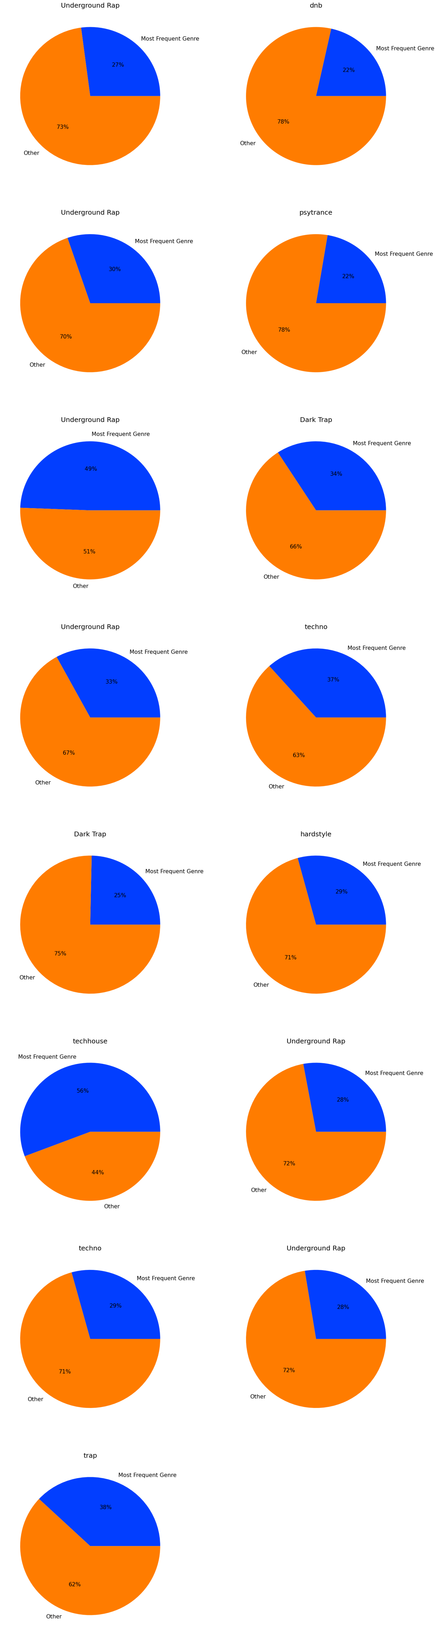

As a result, item profiles based on characteristics derived from things are required. Furthermore, this strategy necessitates the creation of user profiles based on their preferences as well as their platform history.

In the numerator, the calculation is done by calculating dot product of both vectors and in the denominator, the calculation is done by calculating the vector lengths. The obtained value of cosine similarity is between -1 to 1. By sorting the values from the largest to the smallest, the recommendations can be made by choosing several music with the largest cosine similarity. In this research, the number of recommendations is set to be five music. In our experiments, the recommender system uses two methods. The first method only uses the value of cosine similarity, while the second method uses both the value of cosine similarity and information of music genre.

The music which selected by the user is used as the basis music for recommendations. The features of basis music are extraction vector is obtained from the best genre prediction model in previous step. Next, the values of cosine similarity are sorted from the largest to the smallest value. Finally, the first five music with the greatest value is used as recommendations.

**CHAPTER 5**

**DISCUSSION AND CONCLUSION**

**5.1 GIT HUB LINK OF THE PROJECT:**

**5.2 LIMITATIONS:**

1. Cold Start Problem
2. Data Bias
3. Limited Context Awareness
4. Overfitting
5. User Privacy Concerns
6. Changing Tastes
7. Algorithm Transparency
8. Scalability Issues
9. Limited Genre Representation
10. Technical Limitations

**5.3 FUTURE WORK:**

The range of characteristics covered by the recommender system is extensive. In today's generation of e-services and commerce, it is growing and evolving. However, there is a requirement to create and optimise the working and output of the recommender system at the same time. For user convenience and technological simplicity, a dataset can be generated and versioned fully from a single data source. That is, data sources in a dataset cannot be mixed and matched at this time (for example, a dataset built from a GitHub repository cannot include files uploaded from your local system).

We were unable to create a model utilising singular value decomposition and support vector machines due to a lack of time. Because popularity-based models are adept at making suggestions, we'll aim to utilise it to forecast the top-N songs for the users who are most popular at any given time.

Discover Weekly is a 30-song playlist that includes music that are similar to what the user is listening to. This, like its daily mixes and tailored playlists, is made possible by AI and big data. The system also considers the user's streaming history and playlists, as well as their current music preferences, to improve this suggestion.

It will allow users to listen to recommended tracks based on the music or extract. Several service providers provide consumers with a shopping list. However, this is insufficient since consumers have varying preferences and decisions that are influenced by a variety of circumstances and restrictions. It may also be impossible to propose specific things to individual users in many circumstances. As a result, there is potential for combining several dimensions into music recommender systems in particular.

**5.4 CONCLUSION:**

The music recommendation system successfully met its objectives, enhancing user engagement and satisfaction while providing accurate music recommendations. Continuous monitoring and iterative improvements will ensure sustained performance and user enjoyment.

**REFERENCES:**

1. Aiolli, F. (2012). A preliminary study on a recommender system for the million songs dataset challenge. PREFERENCE LEARNING: PROBLEMS AND APPLICATIONS IN AI
2. Spotify. (2013, March) Spotify Music for everyone. [Online].
3. https://www.spotify.com/us/ [10] (2013, March) Wikipedia. [Online]. 4. Peter Knees and Markus Schedl. Music retrieval and recommendation – a tutorial overview. In Proceedings of the 38th Annual International ACM SIGIR Conference on Research and Development in Information Retrieval (SIGIR), Santiago, Chile, August 2015.
4. Peter Knees and Markus Schedl. Music Similarity and Retrieval: AnIntroduction to Audio and Web-based Strategies. 2016.

6. Chris Johnson. From idea to execution: Spotify’s discover weekly. November 2015.